**Department of Electrical and Computer Engineering**

Author: Zainab Hussein

Title: Multicycle Processor (Part 1)

Date: 4-11-2017

1. Time spent: Lab period
2. Table 4

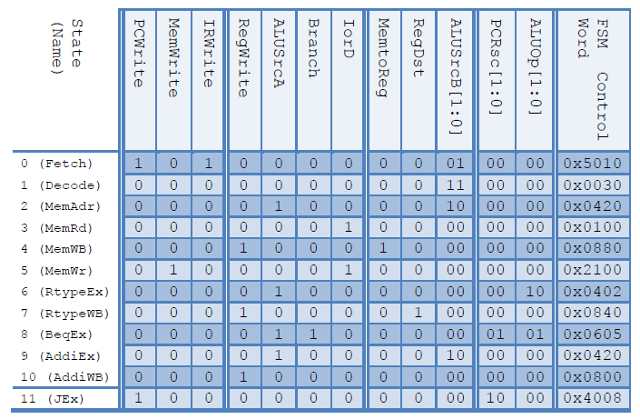

1. Controller, maindec and aludec code

module controller(input logic clk, reset,

input logic [5:0] op, funct,

input logic zero,

output logic pcen, memwrite, irwrite, regwrite,

output logic alusrca, iord, memtoreg, regdst,

output logic [1:0] alusrcb, pcsrc,

output logic [2:0] alucontrol);

logic [1:0] aluop;

logic branch, pcwrite;

assign pcen = pcwrite|(branch&zero);

// Main Decoder and ALU Decoder subunits.

maindec md(clk, reset, op,

pcwrite, memwrite, irwrite, regwrite,

alusrca, branch, iord, memtoreg, regdst,

alusrcb, pcsrc, aluop);

aludec ad(funct, aluop, alucontrol);

// ADD CODE HERE

// Add combinational logic (i.e. an assign statement)

// to produce the PCEn signal (pcen) from the branch,

// zero, and pcwrite signals

endmodule

module maindec(input logic clk, reset,

input logic [5:0] op,

output logic pcwrite, memwrite, irwrite, regwrite,

output logic alusrca, branch, iord, memtoreg, regdst,

output logic [1:0] alusrcb, pcsrc,

output logic [1:0] aluop);

parameter FETCH = 4'b0000; // State 0

parameter DECODE = 4'b0001; // State 1

parameter MEMADR = 4'b0010; // State 2

parameter MEMRD = 4'b0011; // State 3

parameter MEMWB = 4'b0100; // State 4

parameter MEMWR = 4'b0101; // State 5

parameter RTYPEEX = 4'b0110; // State 6

parameter RTYPEWB = 4'b0111; // State 7

parameter BEQEX = 4'b1000; // State 8

parameter ADDIEX = 4'b1001; // State 9

parameter ADDIWB = 4'b1010; // state 10

parameter JEX = 4'b1011; // State 11

parameter LW = 6'b100011; // Opcode for lw

parameter SW = 6'b101011; // Opcode for sw

parameter RTYPE = 6'b000000; // Opcode for R-type

parameter BEQ = 6'b000100; // Opcode for beq

parameter ADDI = 6'b001000; // Opcode for addi

parameter J = 6'b000010; // Opcode for j

logic [3:0] state, nextstate;

logic [14:0] controls;

// state register

always_ff @(posedge clk or posedge reset)

if(reset) state <= FETCH;

else state <= nextstate;

// ADD CODE HERE

// Finish entering the next state logic below. We've completed the first

// two states, FETCH and DECODE, for you.

// next state logic

always_comb

case(state)

FETCH: nextstate <= DECODE;

DECODE: case(op)

LW: nextstate <= MEMADR;

SW: nextstate <= MEMADR;

RTYPE: nextstate <= RTYPEEX;

BEQ: nextstate <= BEQEX;

ADDI: nextstate <= ADDIEX;

J: nextstate <= JEX;

default: nextstate <= 4'bx; // should never happen

endcase

// Add code here

MEMADR: case(op)

LW: nextstate <= MEMRD;

SW: nextstate <= MEMWR;

default: nextstate <= 4'bx; // should never happen

endcase

MEMRD: nextstate <= MEMWB;

MEMWB: nextstate <= FETCH;

MEMWR: nextstate <= FETCH;

RTYPEEX: nextstate <= RTYPEWB;

RTYPEWB: nextstate <= FETCH;

BEQEX: nextstate <= FETCH;

ADDIEX: nextstate <= ADDIWB;

ADDIWB: nextstate <= FETCH;

JEX: nextstate <= FETCH;

default: nextstate <= 4'bx; // should never happen

endcase

// output logic

assign {pcwrite, memwrite, irwrite, regwrite,

alusrca, branch, iord, memtoreg, regdst,

alusrcb, pcsrc, aluop} = controls;

// ADD CODE HERE

// Finish entering the output logic below. We've entered the

// output logic for the first two states, S0 and S1, for you.

always_comb

case(state)

FETCH: controls <= 15'h5010;

DECODE: controls <= 15'h0030;

// your code goes here

MEMADR: controls <= 15'h0420;

MEMRD: controls <= 15'h0100;

MEMWB: controls <= 15'h0880;

MEMWR: controls <= 15'h2100;

RTYPEEX: controls <= 15'h0402;

RTYPEWB: controls <= 15'h0840;

BEQEX: controls <= 15'h0605;

ADDIEX: controls <= 15'h0420;

ADDIWB: controls <= 15'h0800;

JEX: controls <= 15'h4008;

default: controls <= 15'hxxxx; // should never happen

endcase

endmodule

module aludec(input logic [5:0] funct,

input logic [1:0] aluop,

output logic [2:0] alucontrol);

// ADD CODE HERE

// Complete the design for the ALU Decoder.

// Your design goes here. Remember that this is a combinational

// module.

// Remember that you may also reuse any code from previous labs.

// beq, addi, j

always_comb

case(aluop)

2'b00: alucontrol <= 3'b010; // add, lw, sw

2'b10: alucontrol <= 3'b110; // sub

2'b01: alucontrol <= 3'b110; // beq

2'b11: alucontrol <= 3'b001; // ori //ADDED ORI CONTROL SIGNAL

default: case(funct) // RTYPE

6'b100000: alucontrol <= 3'b010; // ADD

6'b100010: alucontrol <= 3'b110; // SUB

6'b100100: alucontrol <= 3'b000; // AND

6'b100101: alucontrol <= 3'b001; // OR

6'b101010: alucontrol <= 3'b111; // SLT

default: alucontrol <= 3'bxxx; // ???

endcase

endcase

endmodule

1. Controllertest testbench

module controllertest();

//inputs

logic clk, reset;

logic [5:0] op, funct;

logic zero;

//outputs

logic pcen, memwrite, irwrite, regwrite;

logic alusrca, iord, memtoreg, regdst;

logic [1:0] alusrcb, pcsrc;

logic [2:0] alucontrol;

// instantiate device to be tested

controller dut(clk, reset, op, funct, zero,

pcen, memwrite, irwrite, regwrite,

alusrca, iord, memtoreg, regdst,

alusrcb, pcsrc,alucontrol);

// generate clock to sequence tests

always

begin

clk <= 1; # 5; clk <= 0; # 5;

end

// initializet est

initial begin

reset= 1 ;

op= 6 'b000000;

zero =0 ;

funct= 6 'b000000;

//lw test

@(posedge clk)#40;

begin

reset= 0 ;

op = 6 'b100011;

zero= 0 ;

funct= 6 'b000000;

end

//sw test

@(posedge clk)#40;

begin

reset= 0 ;

op = 6 'b101011;

zero= 0 ;

funct= 6 'b000000;

end

//add test

@(posedge clk)#40;

begin

reset= 0 ;

op = 6 'b000000;

zero= 0 ;

funct= 6 'b100000;

end

//sub test

@(posedge clk)#40;

begin

reset= 0 ;

op = 6 'b000000;

zero= 0 ;

funct= 6 'b100010;

end

//or test

@ (posedge clk)#40;

begin

reset =0 ;

op= 6 'b000000;

zero= 0 ;

funct =6 'b100101;

end

//slt test

@(posedge clk)#40;

begin

reset =0 ;

op= 6 'b000000;

zero= 0 ;

funct =6 'b101010;

end

//beq test

@(posedge clk)#40;

begin

reset= 0 ;

op = 6 'b000100;

zero= 1 ;

funct= 6 'b000000;

end

//addi test

@(posedge clk)#40;

begin

reset= 0 ;

op = 6 'b001000;

zero= 0 ;

funct= 6 'b000000;

end

//j test

@(posedge clk)#40;

begin

reset= 0 ;

op = 6 'b000010;

zero= 0 ;

funct= 6 'b000000;

end

end

endmodule

1. Simulation waveforms

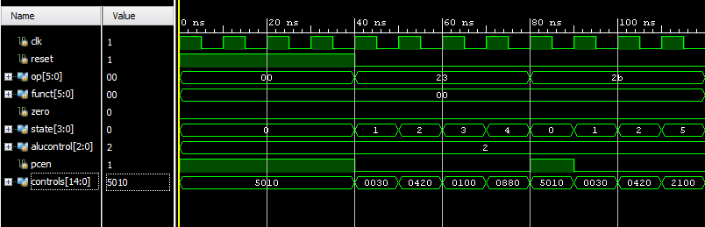

Expected:

lw => Fetch, Decode, MemAddr, MemRead, MemWriteback (states 0,1,2,3,4)

Sw => Fetch, Decode, MemAddr, MemWrite (states 0,1,2,5)

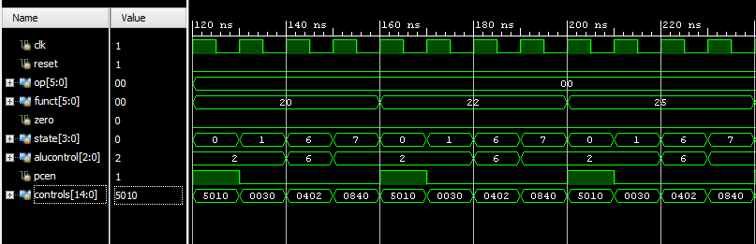

Expected:

add => Fetch, Decode, RtypeEx, RtypeWb (states 0,1,6,7 & funct 20)

sub => Fetch, Decode, RtypeEx, RtypeWb (states 0,1,6,7,0 & funct 22)

or => Fetch, Decode, RtypeEx, RtypeWb (states 0,1,6,7,0 & funct 25)

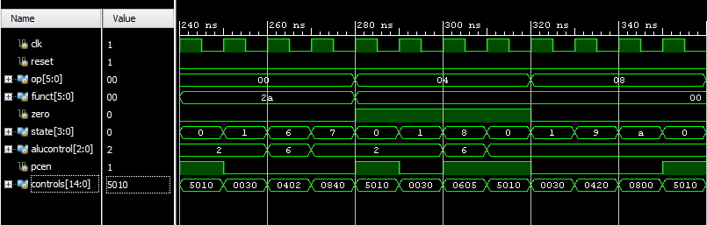

Expected:

slt => Fetch, Decode, RtypeEx, RtypeWb (states 0,1,6,7)

beq => Fetch, Decode, Branch (states 0,1,8)

addi => Fetch, Decode, AddiEx, AddiWb (states 0,1,9,a)

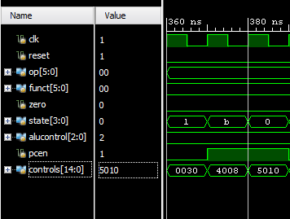

Expected:

j => Fetch, Decode, Jump (states 0,1,b)

Yes, all the simulation matches the expected values outlined in the captions, which correspond to the table 4 and processor state diagram.